**Questions from Dr. Velan:**

1. **Topic:** **Orthographic projection and section of solids**

Q1. A cone with diameter of base 50mm and axis 60mm long, is resting on its base on H.P. It is cut by a section plane inclined at 45° to H.P and passing through the axis at a point 35mm above H.P. Draw the projections of the cut solid.

Sol.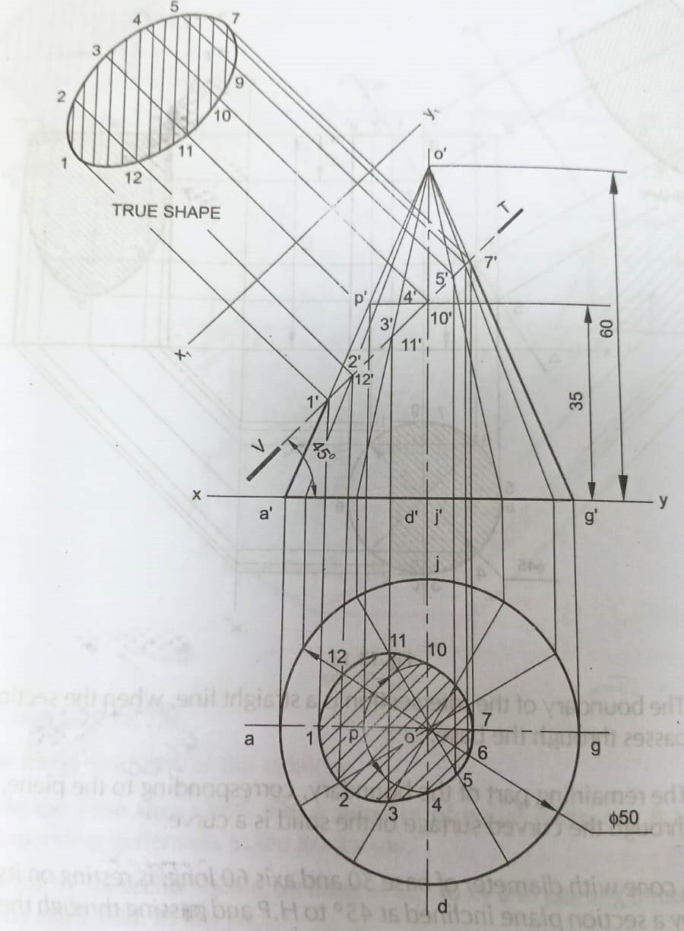

Q2. A pentagonal pyramid of side of base 25mm and 50mm height, rests on a triangular face on H.P, with its axis parallel to V.P. It is cut by a horizontal section plane, bisecting the axis. Draw the projections of the retained solid.

Sol. 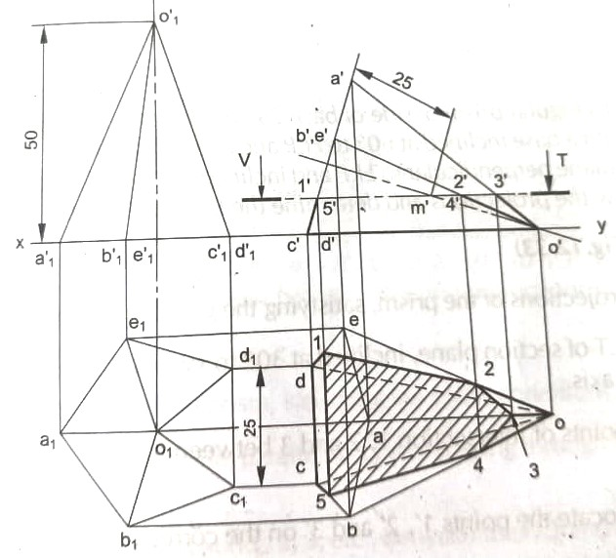

Q3.A pentagonal prism, side of base 25 mm and axis 40mm long is resting on HP on a corner of its base. Draw its projections when the base is inclined at 60 deg to HP and axis appears to be inclined at 30 deg to VP

Sol.

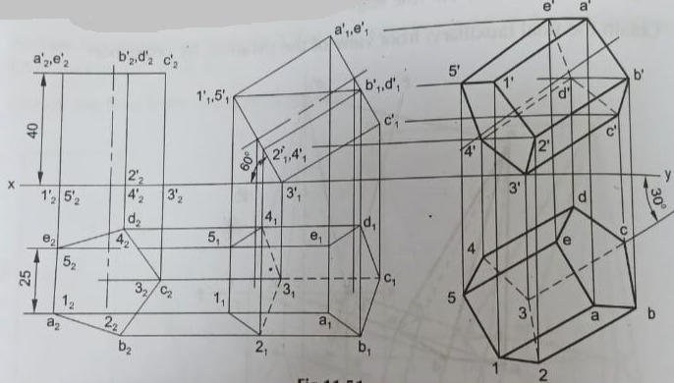

1. **Topic: Orthographic projection of objects**

Q1. Draw the orthographic projection of solid body given below 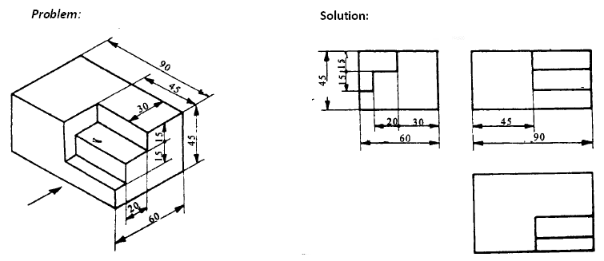

Sol.

Q2. Draw the orthographic projection of solid body given below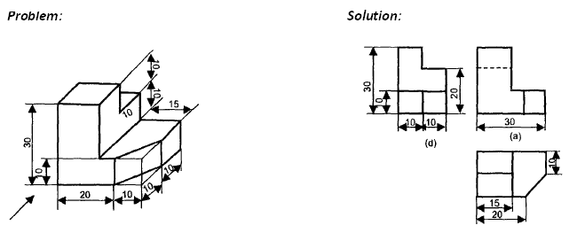

Sol.

Q3. Draw the orthographic projection of solid body given below

Sol. 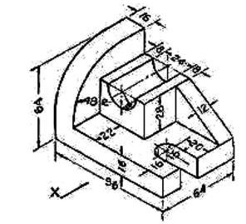

1. **Topic: Isometric view of objects**

Q1.A right circular cone of base diameter 60mm and height 75mm is cut by a plane making an angle of 300 with the horizontal. The plane passes through the mid point of the axis. Draw isometric view of the truncated solid

Sol.

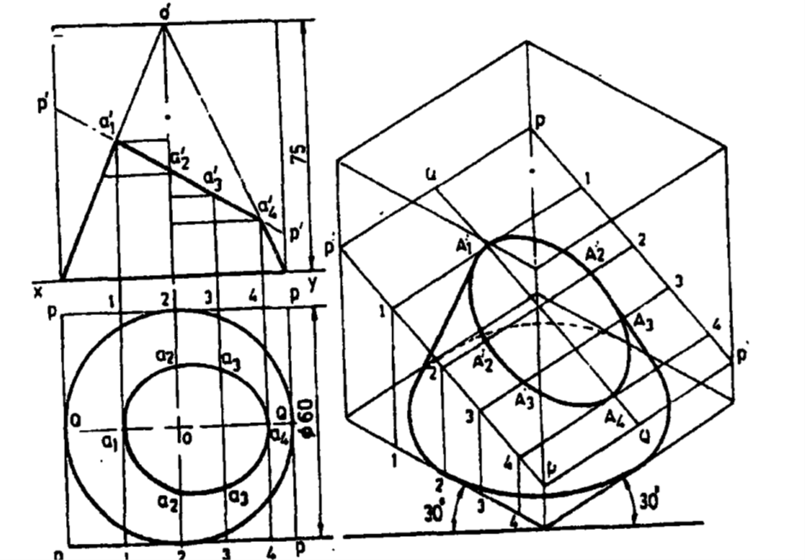

Q2.Draw the isometric view of an object whose projections is given below

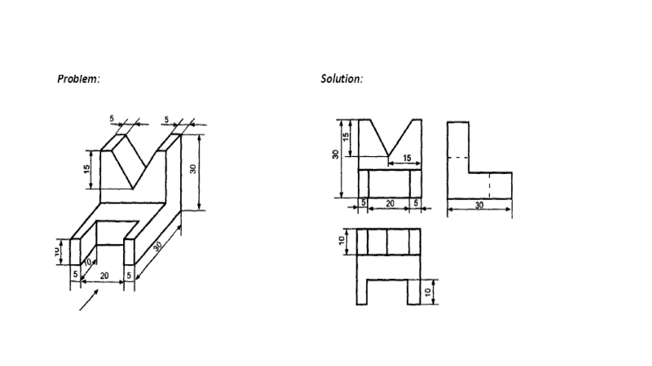

Sol.

Q3.Draw the isometric projection of an object from the below detail drawing.

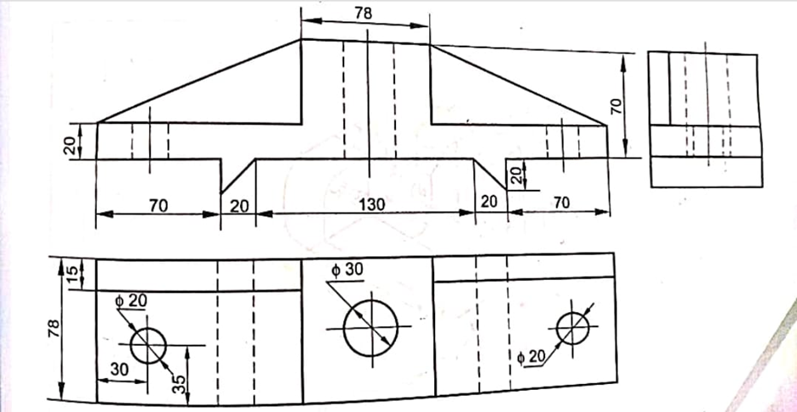

Sol.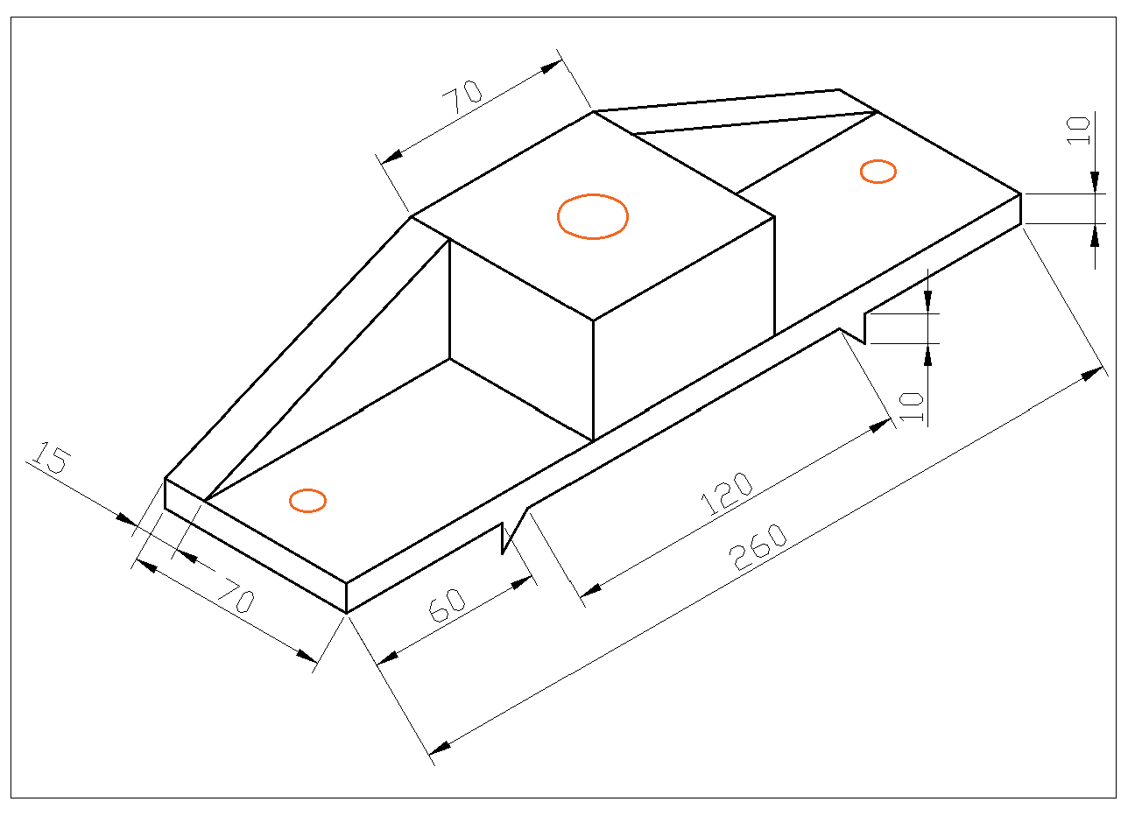

1. **Topic: Intersection of solids/Development of surfaces**

Q1. A vertical cylinder of 120mm dia, is penetrated by another cylinder of 90mm dia. Draw the line of intersection, and its axis is inclined at 30 deg.

Sol.

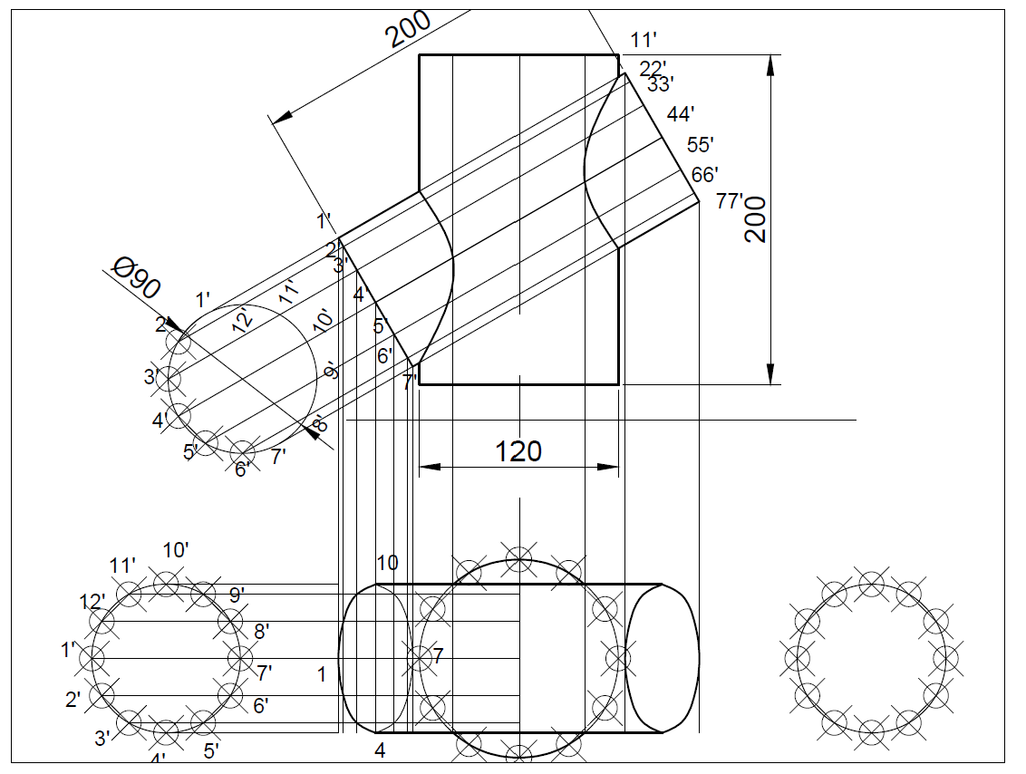

Q2.Problem: A pentagonal pyramid, side of base 50 mm and height 80 mm rests on its base on the ground with one of its base sides parallel to V.P. A section plane perpendicular to VP and inclined at 30° to H.P cuts the pyramid, bisecting its axis. Draw the development of the truncated pyramid

Sol.

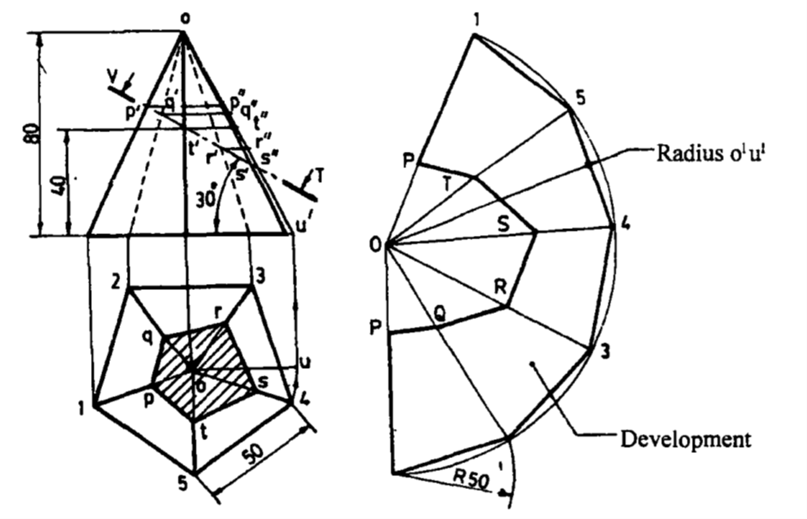

Q3.1. The base of the pentagonal pyramid 30mm is resting on HP and its axis length 60mm parallel to VP. A hole of 15mm side square is drilled through the solid. The axis of the hole is perpendicular to V.P and intersects the axis of the pyramid, at a point 25mm above the base. Draw the development of the pyramid.

Sol.

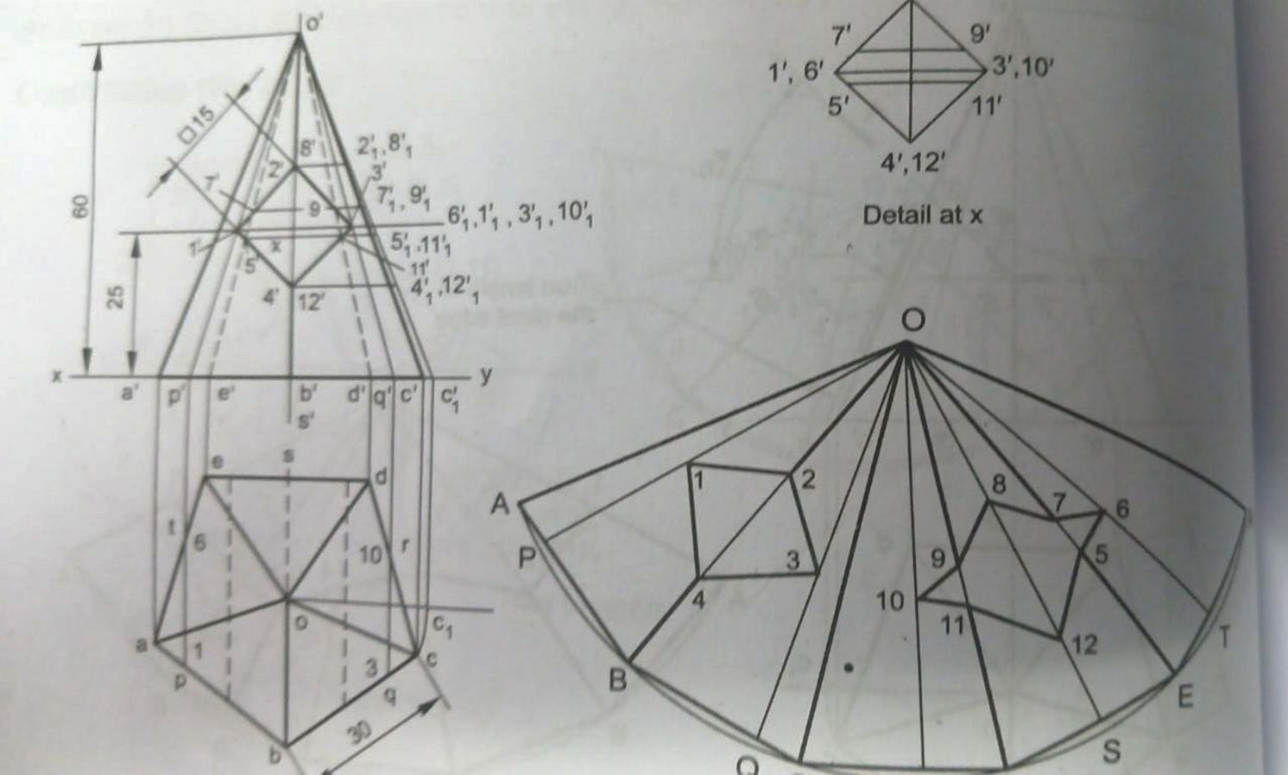

**Questions from Dr. Vikash**

1. **Topic:** **Orthographic projection and section of solids**

Q1.

Sol.

Q2.

Sol.

Q3.

Sol.

1. **Topic: Orthographic projection of objects**

Q1.

Sol.

Q2.

Sol.

Q3.

Sol.

1. **Topic: Isometric view of objects**

Q1.

Sol.

Q2.

Sol.

Q3.

Sol.

1. **Topic: Intersection of solids/Development of surfaces**

Q1.

Sol.

Q2.

Sol.

Q3.

Sol.

**Questions from Dr. Avinash**

1. **Topic:** **Orthographic projection and section of solids**

Q1.

Sol.

Q2.

Sol.

Q3.

Sol.

1. **Topic: Orthographic projection of objects**

Q1.

Sol.

Q2.

Sol.

Q3.

Sol.

1. **Topic: Isometric view of objects**

Q1.

Sol.

Q2.

Sol.

Q3.

Sol.

1. **Topic: Intersection of solids/Development of surfaces**

Q1.

Sol.

Q2.

Sol.

Q3.

Sol.

**Questions from Dr. Basheer**

1. **Topic:** **Orthographic projection and section of solids**

Q1.

Sol.

Q2.

Sol.

Q3.

Sol.

1. **Topic: Orthographic projection of objects**

Q1.

Sol.

Q2.

Sol.

Q3.

Sol.

1. **Topic: Isometric view of objects**

Q1.

Sol.

Q2.

Sol.

Q3.

Sol.

1. **Topic: Intersection of solids/Development of surfaces**

Q1.

Sol.

Q2.

Sol.

Q3.

Sol.